Bug Report for Quantum Wave Interference Version 1.0
Sam McKagan
May 31, 2006

- In Java version 1.4.2_03, the slider leaves a little trail when you move it and has a green rectangle behind the tick marks (see below). This problem does not appear in Java version 1.5.0_04 or 1.5.0_06.
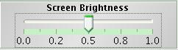
- For photons in High Intensity panel, turning on detector changes display from time-averaged intensity to E-field.
- For massive particles in High Intensity panel, turning on detector changes display from phase color to magnitude.
- If you start in E-field view and turn off detector, view changes temporarily to time-averaged intensity in upper half of box. This effect also happens for electrons.
- Changing the particle type often messes up the wave function display. If you change the wave function display for one type of particle and then switch to a different type of particle, the actual display is the same as for the particle you just switched from, but the radio button for the display corresponds to whatever was last selected for the new type of particle, so that the radio button and the actual display don’t match.
- In “hits” mode, the dots appear on the screen in columns, so it appears that there are many very thin interference fringes:
- The “one-shot” checkbox doesn’t work. If auto-detect is checked, the detector is always one-shot, regardless of whether one-shot is checked or not. If auto-detect is off, the detector always allows multiple detections, regardless of whether one-shot is checked or not. The detector should never allow multiple detections of a single particle if one-shot is checked, and should always allow multiple detections if one-shot is unchecked.
- If you put a detector over each slit in the single particle panel and detect the particles manually, rather than using auto-detect, it doesn’t seem to be equally likely to detect the particle in either detector, even though the probabilities written in both detectors are the same. It almost always detects the particle in the first detector that you put on the screen. At first I thought that the other detector wasn’t activated, but if you do it enough times, the other detector will occasionally detect it.
- For certain values of screen brightness in the two lasers panel, if there are two lasers of different colors that are both at maximum intensity, the pattern on the screen is asymmetric (this caused considerable confusion for student, and was much more noticeable in the interview than it is in this screen shot):
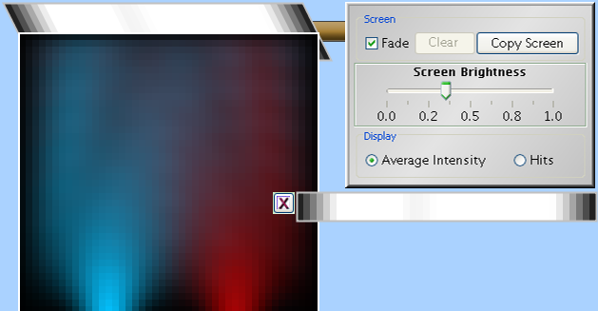
Note darker spot on left but not right.
- If I resize the simulation to full screen at 1280x1024 resolution, a bit of text that says “Off” appears next to the left laser in the two lasers panel:


